**Assignment 01**

Q1.

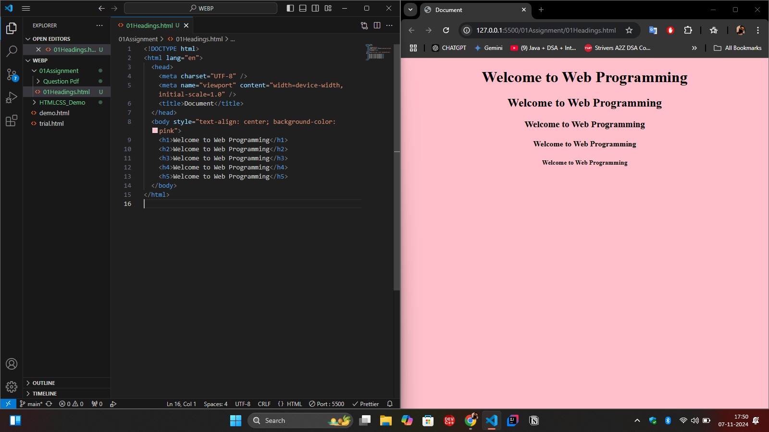

Q2.

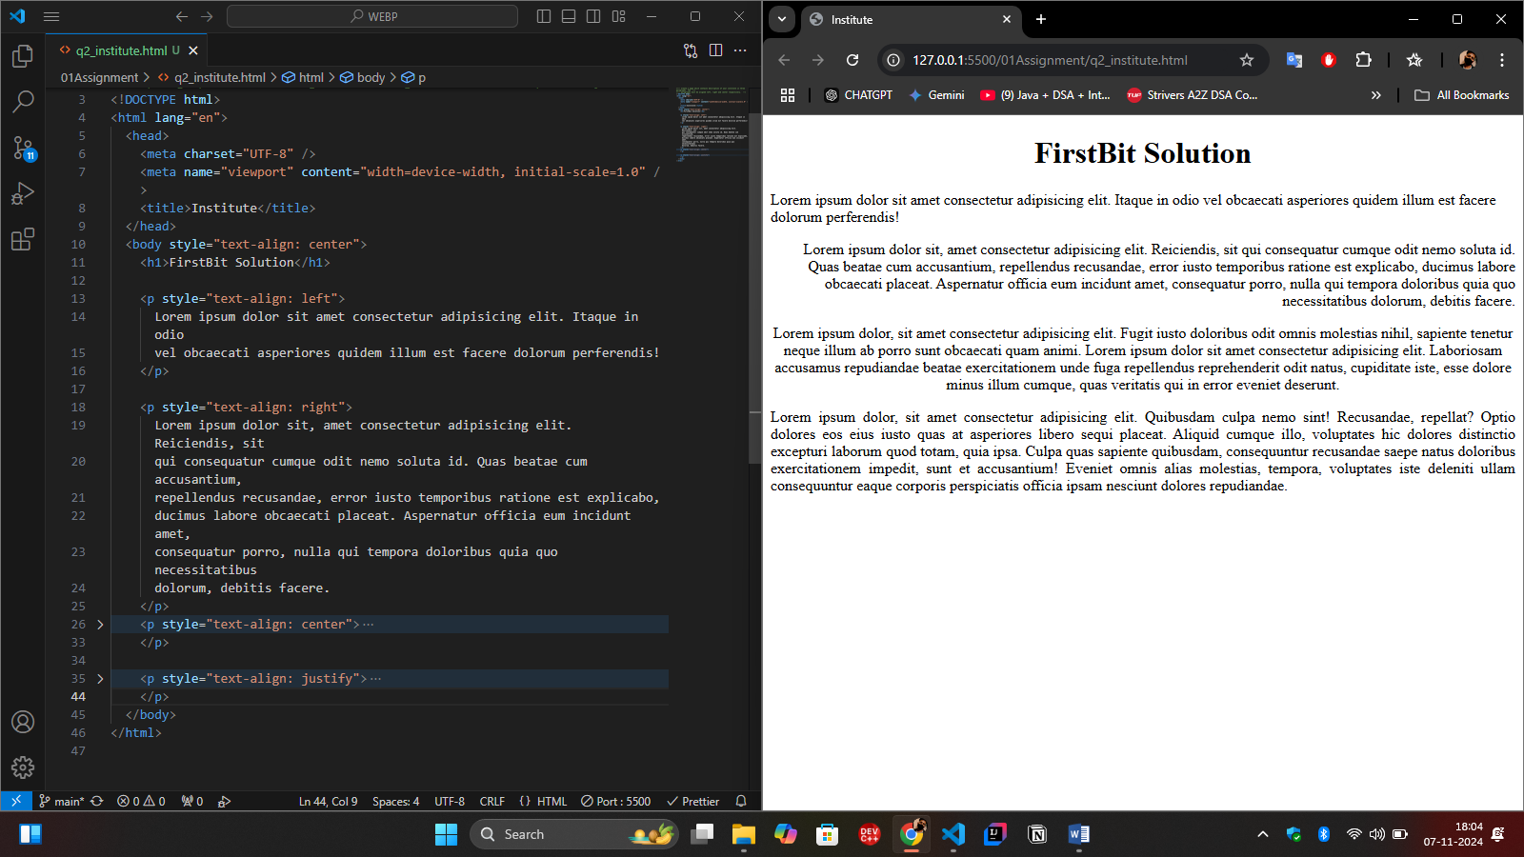

Q3.

<!DOCTYPE html>

<html lang="en">

  <head>

    <meta charset="UTF-8" />

    <meta name="viewport" content="width=device-width, initial-scale=1.0" />

    <title>Document</title>

  </head>

  <body style="margin: 0.4%">

    <table border="1px" width="100%">

      <tr>

        <td>

          <span>Sports:</span>

          <ul>

            <li>Footboll</li>

            <li>Base Boll</li>

            <li>Cricket</li>

          </ul>

        </td>

        <td>

          <span>Fruits:</span>

          <ul style="list-style: square">

            <li>Banana</li>

            <li>Apple</li>

            <li>Grapes</li>

          </ul>

        </td>

        <td>

          <span>Players:</span>

          <ul style="list-style: circle">

            <li>Batman</li>

            <li>Bowler</li>

            <li>Fielder</li>

            <li>Wicket Keeper</li>

          </ul>

        </td>

      </tr>

      <tr>

        <td>

          <span>Subjects :</span>

          <ol>

            <li>C Programming</li>

            <li>OOP</li>

            <li>Data Structures</li>

          </ol>

        </td>

        <td>

          <span>Topics :</span>

          <ol type="I">

            <li>Selection Statement</li>

            <li>Control Statement</li>

            <li>Functions</li>

          </ol>

        </td>

        <td>

          <span>Employees :</span>

          <ol type="A">

            <li>Programmer</li>

            <li>Admin</li>

            <li>Sales Manager</li>

          </ol>

        </td>

      </tr>

      <tr>

        <td colspan="3">

          <h5>Web Development</h5>

          <p style="text-align: justify">

            Web development is a broad term for the work involved in developing

            a web site for the Internet (World Wide Web) or an intranet (a

            private network). This can include web design, web content

            development, client liaison, client-side/server-side scripting, web

            server and network security configuration, and e-commerce

            development. However, among web professionals, "web development"

            usually refers to the main non-design aspects of building web sites:

            writing markup and coding. Web development can range from developing

            the simplest static single page of plain text to the most complex

            web-based internet applications, electronic businesses, or social

            network services.

          </p>

          <h5>Web development as an industry</h5>

          <p style="text-align: justify">

            Since the mid-1990s, web development has been one of the fastest

            growing industries in the world. In 1995 there were fewer than 1,000

            web development companies in the United States, but by 2005 there

            were over 30,000 such companies[citation needed] in the U.S. alone.

            The growth of this industry is being pushed by large businesses

            wishing to sell products and services to their customers and to

            automate business workflow.

          </p>

          <h5>Security Considerations</h5>

          <p style="text-align: justify">

            Web development takes into account many security considerations,

            such as data entry error checking through forms, filtering output,

            and encryption.[1] Malicious practices such as SQL injection can be

            executed by users with ill intent yet with only primitive knowledge

            of web development as a whole. Scripts can be exploited to grant

            unauthorized access to malicious users trying to collect information

            such as email addresses, passwords and protected content like credit

            card numbers.

          </p>

        </td>

      </tr>

    </table>

  </body>

</html>

Op: 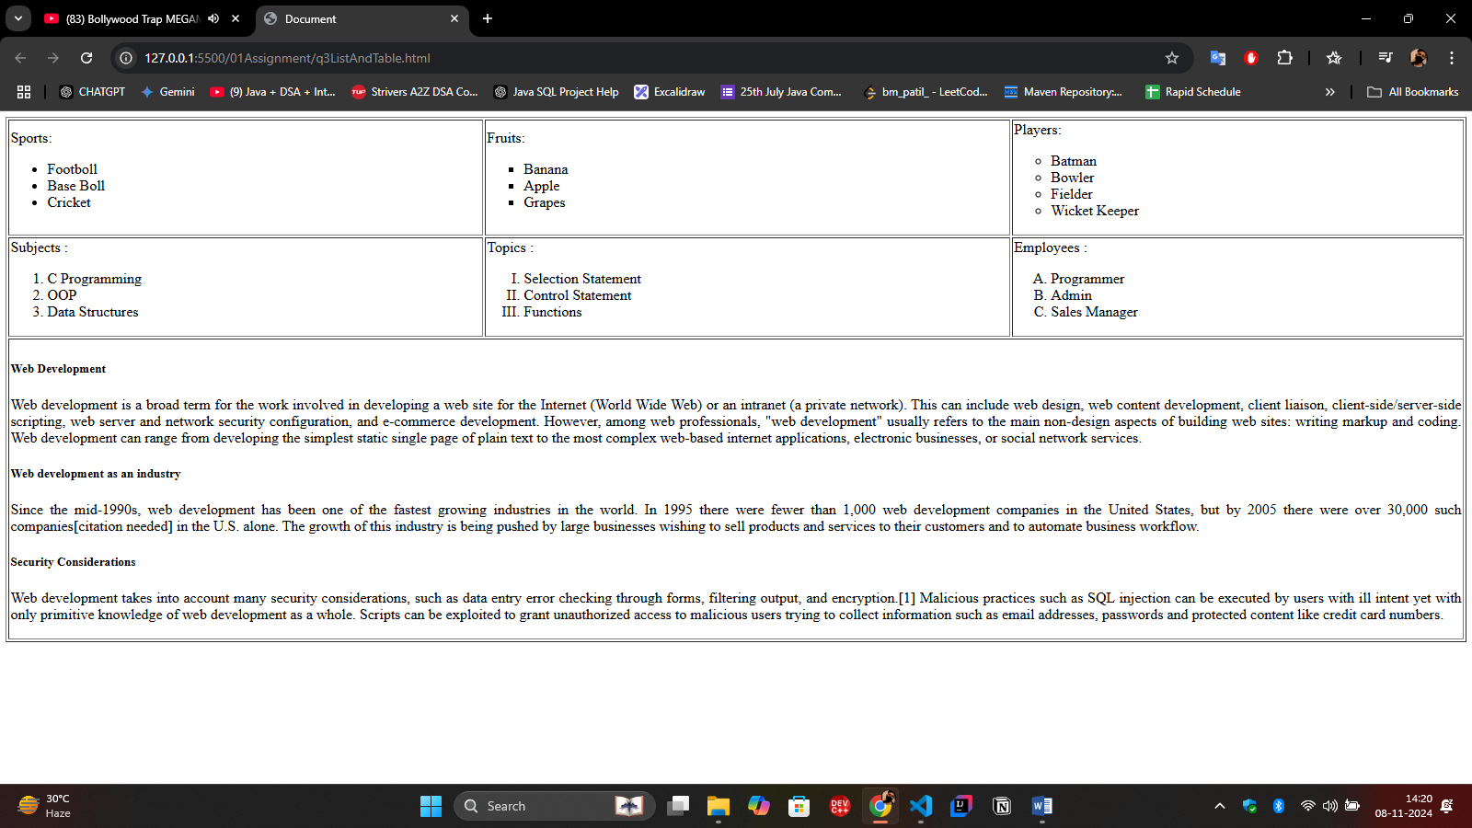

Q4.

<!DOCTYPE html>

<html lang="en">

  <head>

    <meta charset="UTF-8" />

    <meta name="viewport" content="width=device-width, initial-scale=1.0" />

    <title>Images</title>

    <style>

      .images {

        flex-direction: wrap;

      }

    </style>

  </head>

  <body>

    <div class="images">

      <img

        src="./images/gallery-1.png"

        alt=""

        height="400px"

        border="5px"

        style="border-color: blueviolet"

      />

      <img src="./images/gallery-2.png" alt="" height="200px" border="4px" />

      <img src="./images/gallery-3.png" alt="" height="200px" border="4px" />

      <img

        src="./images/program-1.png"

        alt=""

        width="400px"

        height="400px"

        style="border: 5px dotted red"

      />

      <img

        src="./images/program-2.png"

        alt=""

        width="400px"

        height="400px"

        style="border: 5px solid red"

      />

      <img

        src="./images/program-3.png"

        alt=""

        width="400px"

        height="400px"

        style="border: 5px dotted  red"

      />

      <img

        src="./images/user-1.png"

        alt=""

        height="400px"

        width="400px"

        style="border: 5px double violet"

      />

      <img

        src="./images/user-2.png"

        alt=""

        height="350px"

        width="350px"

        style="border: 10px groove magenta"

      />

      <img

        src="./images/user-3.png"

        alt=""

        height="300px"

        width="300px"

        style="border: 10px double red"

      />

      <img

        src="./images/user-4.png"

        alt=""

        height="200px"

        width="200px"

        style="border: 5px dotted red"

      />

    </div>

  </body>

</html>

Op: 

Q5: <!DOCTYPE html>

<html lang="en">

  <head>

    <meta charset="UTF-8" />

    <meta name="viewport" content="width=device-width, initial-scale=1.0" />

    <title>Color Boxes</title>

    <style>

      .color-box {

        height: 20px;

        width: 20px;

      }

    </style>

  </head>

  <body>

    <table style="text-align: right">

      <tr>

        <td>red</td>

        <td><div class="color-box" style="background-color: red"></div></td>

      </tr>

      <tr>

        <td>blue</td>

        <td><div class="color-box" style="background-color: blue"></div></td>

      </tr>

      <tr>

        <td>green</td>

        <td><div class="color-box" style="background-color: green"></div></td>

      </tr>

      <tr>

        <td>orange</td>

        <td><div class="color-box" style="background-color: orange"></div></td>

      </tr>

    </table>

  </body>

</html>

Op

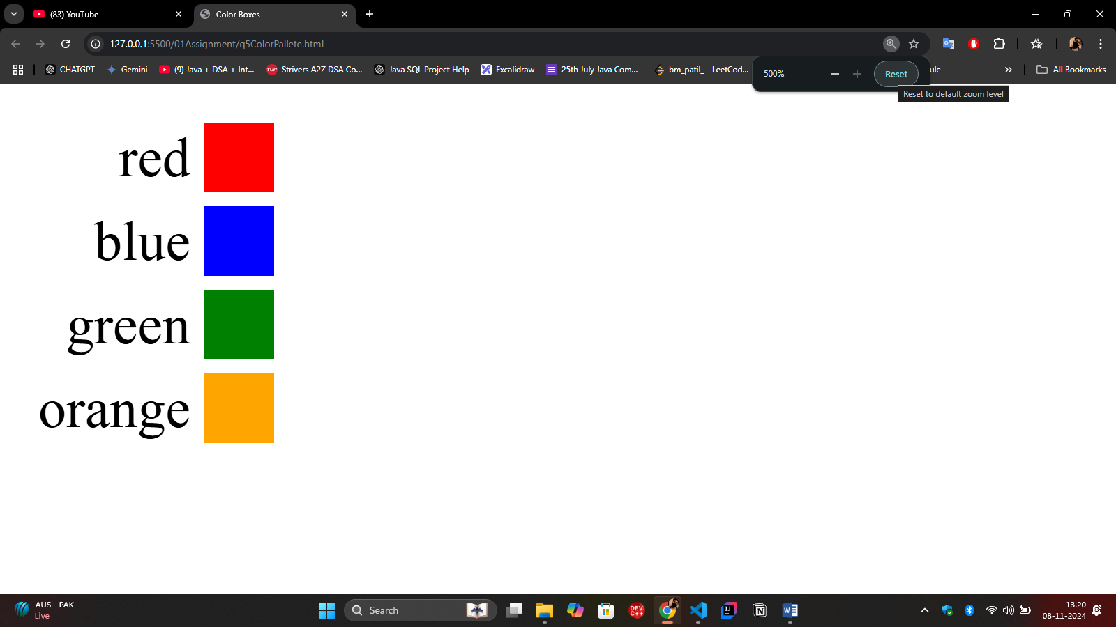

Q6

<!DOCTYPE html>

<html lang="en">

  <head>

    <meta charset="UTF-8" />

    <meta name="viewport" content="width=device-width, initial-scale=1.0" />

    <title>Time Table</title>

    <style>

      td {

        padding: 10px;

      }

      .time {

        font-weight: 600;

      }

    </style>

  </head>

  <body>

    <table border="10px" style="padding: 5px; width: 500px">

      <tr>

        <th></th>

        <th>Monday</th>

        <th>Tuesday</th>

        <th>Wednsday</th>

        <th>Thursday</th>

        <th>Friday</th>

      </tr>

      <tr>

        <td class="time">1:00</td>

        <td rowspan="2" style="background-color: rgb(248, 188, 109)">Office</td>

        <td></td>

        <td rowspan="2" style="background-color: rgb(248, 188, 109)">Office</td>

        <td rowspan="8">Office Hours by Appt</td>

        <td

          rowspan="2"

          style="background-color: rgb(248, 188, 109); text-align: center"

        >

          Office

        </td>

      </tr>

      <tr>

        <td class="time">1:30</td>

        <td rowspan="2" style="background-color: rgb(158, 158, 158)">

          Dept Meeting

        </td>

      </tr>

      <tr>

        <td class="time">2:00</td>

        <td rowspan="3" style="background-color: rgb(9, 255, 0)">MAT 108</td>

        <td rowspan="3" style="background-color: rgb(9, 255, 0)">MAT 108</td>

        <td rowspan="3" style="background-color: rgb(9, 255, 0)">MAT 108</td>

      </tr>

      <tr>

        <td class="time">2:30</td>

        <td></td>

      </tr>

      <tr>

        <td class="time">3:00</td>

        <td rowspan="3" style="background-color: rgb(158, 158, 158)">

          EC Meeting

        </td>

      </tr>

      <tr>

        <td class="time">3:30</td>

        <td rowspan="3" style="background-color: rgb(252, 121, 234)">

          CSC 205

        </td>

        <td rowspan="3" style="background-color: rgb(252, 121, 234)">

          CSC 205

        </td>

        <td rowspan="3" style="background-color: rgb(252, 121, 234)">

          CSC 205

        </td>

      </tr>

      <tr>

        <td class="time">4:00</td>

      </tr>

      <tr>

        <td class="time">4:30</td>

        <td></td>

      </tr>

    </table>

  </body>

</html>

Op: 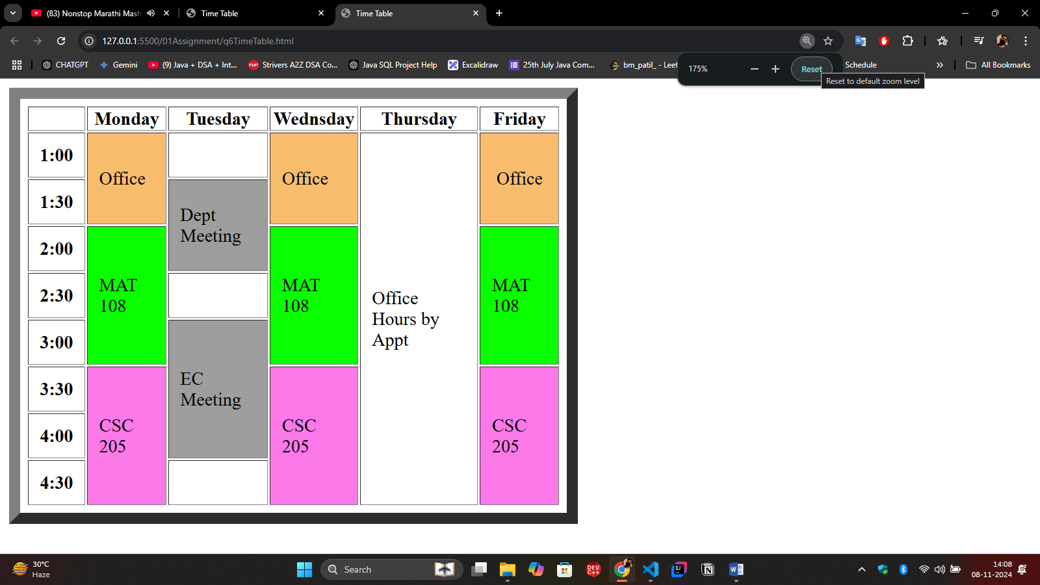

Q7:

